Unit 10

Correlation and Regression

Introduction
In this unit consideration is given to measuring association between variables and if they are linked theoretically then how one can build a model of the relationship. We will begin with only two variables and in later more variables will be introduced.

- Correlation

The Pearson’s Product Moment Correlation Coefficient is a measure of the degree of association between variables. It takes a value between -1 and 1. A value of r near to 1 indicates strong positive association e.g. a person's height and weight, whereas a value of r near to -1 indicates a strong negative linear association, e.g. amount to drink and performance in a test. And when r = ± 1 indicates perfectly correlated i.e., all the points are on the line.

Positive Correlation (r > 0) Negative Correlation (r < 0)

No Significant Correlation

The Pearson’s correlation coefficient is computed from:

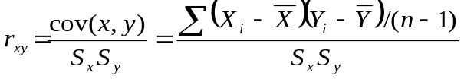;

This formula is available in most packages including SPSS. SPSS also gives a significance level, if this is less than 0.05 then the coefficient is judged significant. However, one should not consider the coefficient on its own, scatter plots should also be examined. The following illustrates the dangers of ignoring the plots.

Outlier effect turns r = 0 .002 to r = 0.91. The outlying point should perhaps be removed. | Non - linear relationship (r = -0.02). The Pearson correlation coefficient is purely a measure of linear association. Yet many variables have strong non-linear association, such as economies of scale.

As an example of using Excel, load the file Houses.xls and go to Tools and Data Analysis and then Correlation and enter the variables, Price, Age, Area and Totrooms (total rooms).

A Correlation Matrix for selected four variables

 | PRICE | AGE | AREA | TOTROOMS
PRICE | 1
AGE | 0.348 | 1
AREA | 0.958 | 0.389 | 1
TOTROOMS | 0.556 | 0.175 | 0.504 | 1

A matrix scatter plot is also helpful but unfortunately Excel software does not provide such a diagram.

Thus a strong positive correlation is suggested between Price and Area, a lesser correlation between Price and Totrooms; between Area and Totrooms; and a weaker correlation between Price and Age; and between Age and Area.

- Regression

“Finding a relationship between variables and forming a model”. Hence this is a major tool of statistical modelling.

An equation may be developed with independent variables which have stimuli or influence on a dependent variable or response. This method was first developed by Legendre in 1805.

Assumptions:

- The relationship is sensible.
- The relationship is linear.
- Errors are independent and normally distributed.

Linear Regression is often used to explain changes in some phenomenon as a result of influencing variables. This involves estimating the coefficients of the explanatory variable or independent variables or stimuli that go to predict the dependent variable or response. Consider the example of a restaurant owner who thinks that sales of pizzas in cities are dependent primarily on the size of the student population. To test this he gathers the data, which is tabulated below:

City | Student Population (1000s) | Annual sales (£1000s)
1 | 2 | 58
2 | 6 | 105
3 | 8 | 88
4 | 8 | 118
5 | 12 | 117
6 | 16 | 137
7 | 20 | 157
8 | 20 | 169
9 | 22 | 149
10 | 26 | 202

To test this, the data is first plotted on a scatter diagram and is displayed below:

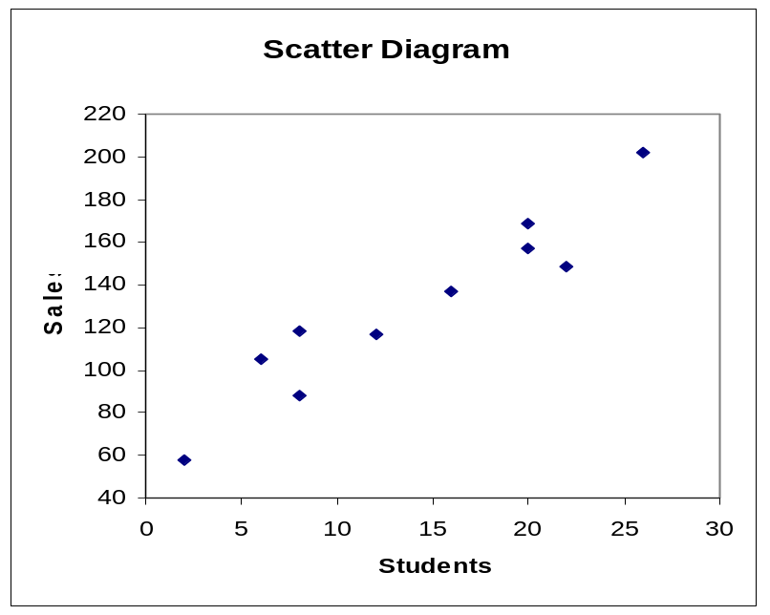

It looks although a straight-line positive relationship may hold indeed the correlation coefficient is 0.905 with a P value = 0.000. Plot the “best” straight line through the data and calculate the equation of the line. Regression is a way of doing this and estimates the coefficients or parameters of the model:
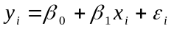

in such away that the sum of squares of the errors, or residuals, are minimised i.e.:

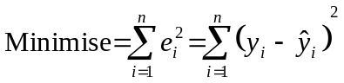

The restaurant owner uses Excel to compute the equation by going to Tools, then Data Analysis, selecting Regression and enter sales as the dependant and student population as the independent. The owner then gets the following output:

Simple regression analysis
SUMMARY OUTPUT

Regression Statistics
Multiple R |  | 0.95012
R Square |  | 0.90273
Adjusted R Square |  | 0.89058
Standard Error |  | 13.82932
Observations |  | 10

ANOVA
 | SS | MS | df | F | Sig F
Regression | 14200 | 14200 | 1 | 74.2484 | 0.0000
Residual | 1530 | 191.25 | 8
Total | 15730 |  | 9
 | Standard Error | t Stat | Coefficients | P-value | Lower 95% |  | Upper 95%
Intercept | 9.2260 | 6.5033 | 60 | 0.0002 | 38.7247 |  | 81.2753
STUDENTS | 0.5803 | 8.6167 | 5 | 0.0000 | 3.6619 |  | 6.3381

This gives the model: Pizza Sales = 60 + 5 * students which means that for every additional 1,000 students annual pizza sales increase by £5,000.
Is this any good? Is it reliable?
The value R² is the coefficient of determination and is often used as a test of quality. This is calculated as:

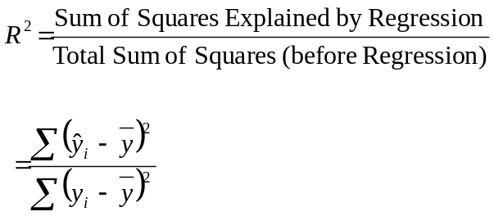

In this case R² is over 90% and suggests that 90% of the variation in the sales of pizzas is explained by the model. Generally one wishes R² to be as close to 100% as possible. However, it is dangerous to rely solely on R². One must consider the assumptions behind the model and diagnose the model accordingly.

The assumptions to consider are:

- The model makes theoretical sense.
- The errors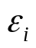are independent of one another (uncorrelated) and normally distributed with mean zero.
- The parameters are constant over time

- Diagnostics

To diagnose the model with respect to these assumptions the following methods are available:

1. Is the relationship sensible?
2. Examine the signs of the coefficients - are they sensible?
3. Test the errors for a zero mean and for normality. To do this one can look at a normal probability plot (normal P-P plot in Excel) of the residuals. (The residuals are the observed values minus the fitted values).

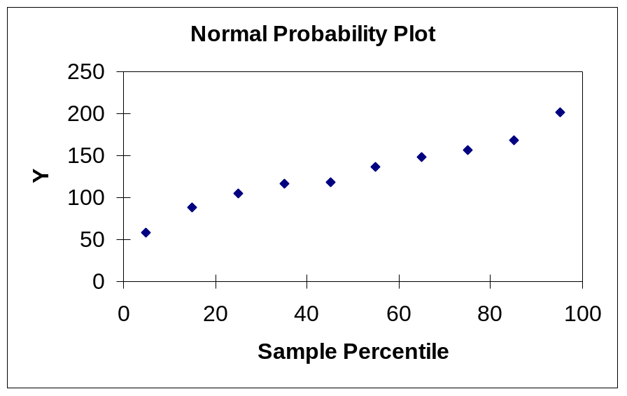

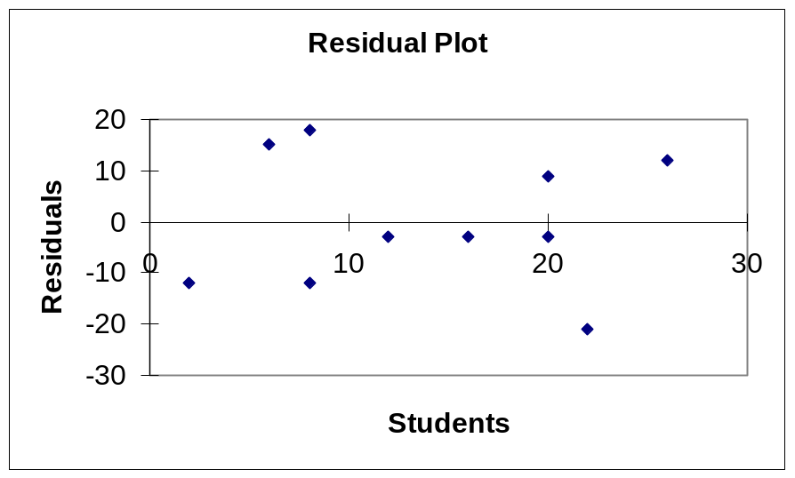

The residuals should always be plotted against the predicted values. They can also be plotted against the explanatory variable, (why?).

This analysis allows correlation to be detected, non-constant variance (heteroscadisity) and influencing points to be detected. Fortunately the residuals appear randomly scattered as was hoped for. Often one will work with the standardised residuals (SR). These are computed automatically from 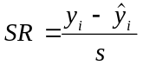 were s is the standard deviation of the residuals. Absolute values of SR > 3 indicate a probable deviant requiring investigation. Absolute values of SR > 2 but < 3 indicate a possible deviant.

Are the coefficients significantly different from zero?

To assess this they are compared to their standard errors and if they are then they should be approximately more than twice their standard error, (why?). More formally the t-ratio is computed from
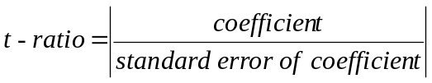
This is tested against the Student t distribution i.e. the T ratio is compared to 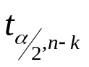
where k = the number of parameters including 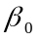

The hypothesis H₀: the coefficient is not significantly different from zero

is tested against

H₁: the coefficient is significantly different from zero

Reject the null hypothesis (H₀) if the T ratio is less than the table value.

The F test allows one to test if a linear form between y and x exists. The test is

H₀: All the 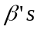equal zero
V
H₁: At least one of the do not equal zero.

This is compared to the F- distribution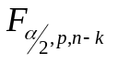, where p is the number of independent variables. For both the above tests P values are computed automatically by most computer packages.

Multiple Regression

This is an extension of the previous idea and the concept is to build models with several explanatory variables:

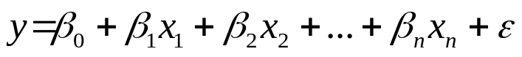

where y is the response and the independent variables are those which “explain” the response. For example demand for electricity might be explained by family size, amount of consumer durable, temperature, time of day, day of week and so forth. Determining, specifying and measuring these independent variables can be difficult.

Consider the case of a researcher investigating the hours of television watched per day by male pensioners. Data has been collected on the average number of hours watched, the pensioners marital status, (coded 0 if unmarried and 1 if married), their age and their years of education. The data collected is:

Hours Mstatus Age Yrs_Ed
.50 1.00 73.00 14.00
.50 1.00 66.00 16.00
.70 .00 65.00 15.00
.80 .00 65.00 16.00
.80 1.00 68.00 9.00
.90 1.00 69.00 10.00
1.10 1.00 82.00 12.00
1.60 1.00 83.00 12.00
1.60 1.00 81.00 12.00
2.00 .00 72.00 10.00
2.50 1.00 69.00 8.00
2.80 .00 71.00 16.00
2.80 .00 71.00 12.00
3.00 .00 80.00 9.00
3.00 .00 73.00 6.00
3.00 .00 75.00 6.00
3.20 .00 76.00 10.00
3.20 .00 78.00 6.00
3.30 1.00 79.00 6.00
3.30 .00 79.00 4.00
3.40 1.00 78.00 6.00
3.50 .00 76.00 9.00
3.60 .00 65.00 12.00
3.70 .00 72.00 12.00
3.70 .00 80.00 6.00

The dependent variable is graphed against each of the independent variables:
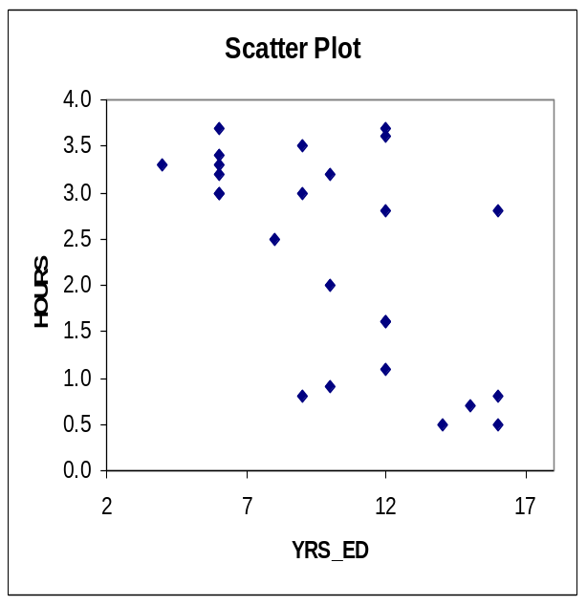
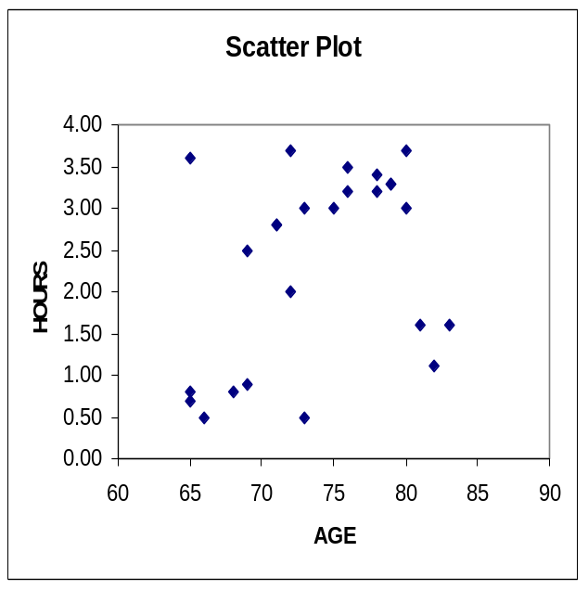

This shows that there is a weak positive link between hours and age. There is a cluster of over-80 year-olds who buck the trend - perhaps these people are very ill. Hours watched appears to drop with years of education. Married pensioners seem to watch less than unmarried ones. These relationships are confirmed when correlations are computed:

Correlation Matrix
 | HOURS | AGE | YRS_ED
HOURS | 1
AGE | 0.358 | 1
YRS_ED | -0.612 | -0.501 | 1

Thus the view obtained from the graphs is supported. Conducting the modelling in Excel:

Thus the coefficient of determination is 57%, clearly there is variability still to be explained. What other variables would you wish to use?

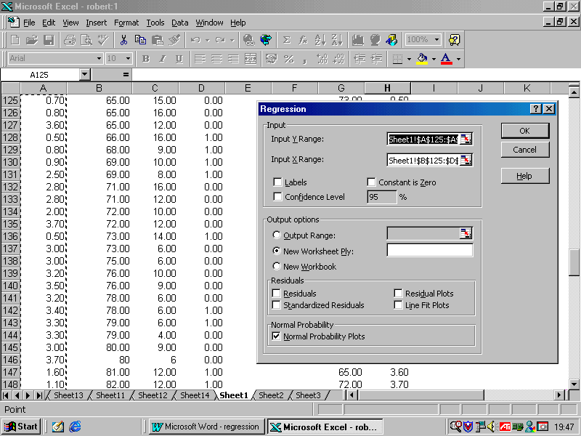

SUMMARY OUTPUT
Regression Statistics
Multiple R | 0.791
R Square | 0.626
Adjusted R Square | 0.572
Standard Error | 0.754
Observations | 25

ANOVA
 | df | SS | MS | F | Significance F
Regression | 3 | 19.933 | 6.644 | 11.698 | 0.000
Residual | 21 | 11.927 | 0.568
Total | 24 | 31.86
 | Coefficients | Standard Error | t Stat | P-value | Lower 95% | Upper 95% | Lower 95.0% | Upper 95.0%
Intercept | 1.495 | 2.637 | 0.567 | 0.577 | -3.989 | 6.980 | -3.989 | 6.980
Age | 0.039 | 0.032 | 1.214 | 0.238 | -0.028 | 0.105 | -0.028 | 0.105
Yrs_Ed | -0.152 | 0.050 | -3.039 | 0.006 | -0.256 | -0.048 | -0.256 | -0.048
Mstatus | -1.176 | 0.316 | -3.726 | 0.001 | -1.832 | -0.519 | -1.832 | -0.519
Dependent variable: Hours
Predictors: Age, YRS_ED, MSTATUS

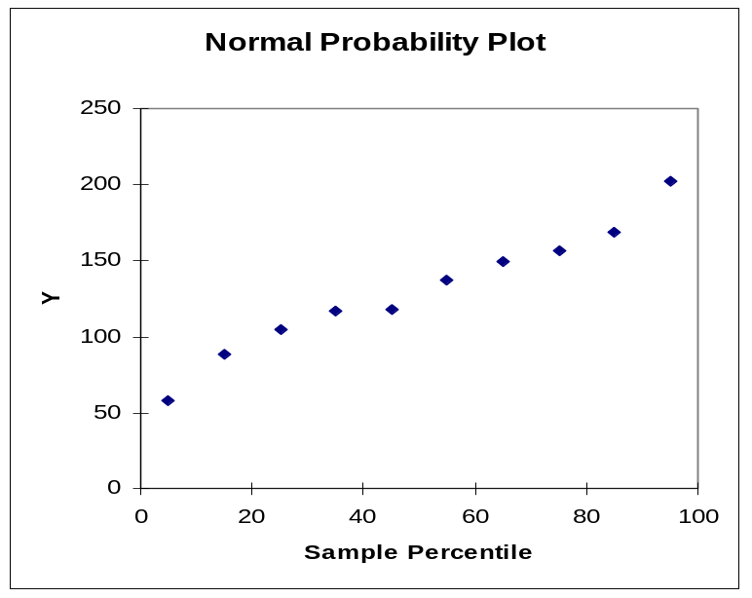

Thus there is evidence of a significant relationship.

This suggests that age is not a significant factor in explaining hours of TV watched. Thus marital status has the biggest effect, and then years of education and age has the least effect.

What if those over 80 years old were removed?

SUMMARY OUTPUT
Regression Statistics
Multiple R |  | 0.783
R Square |  | 0.613
Adjusted R Square |  | 0.549
Standard Error |  | 0.788
Observations |  | 22
ANOVA
 |  | df | SS | MS | F | Significance F
Regression |  | 3 | 17.7119 | 5.9040 | 9.5062 | 0.000552982
Residual |  | 18 | 11.1790 | 0.6211
Total |  | 21 | 28.8909
 |  | Coefficients | Standard Error | t Stat | P-value | Lower 95% | Upper 95%
Intercept |  | -1.624 | 4.243 | -0.383 | 0.706 | -10.537 | 7.289
Age |  | 0.076 | 0.051 | 1.493 | 0.153 | -0.031 | 0.182
Yr_Ed |  | -0.110 | 0.068 | -1.626 | 0.121 | -0.253 | 0.032
Mstatus |  | -1.016 | 0.369 | -2.751 | 0.013 | -1.792 | -0.240

So age is still not significant. The R-squared value also deteriorated to 55%.

A key concept in modelling is the principle of parsimony - which is to try and explain the response as simply and with as few terms as possible. Thus age should go and we get:

SUMMARY OUTPUT
Regression Statistics
Multiple R |  | 0.774
R Square |  | 0.599
Adjusted R Square |  | 0.563
Standard Error |  | 0.762
Observations |  | 25
ANOVA
 |  | df | SS | MS | F | Significance F
Regression |  | 2 | 19.096 | 9.548 | 16.456 | 0.000
Residual |  | 22 | 12.764 | 0.580
Total |  | 24 | 31.86
 |  | Coefficients | Standard Error | t Stat | P-value | Lower 95% | Upper 95%
Intercept |  | 4.646 | 0.473 | 9.823 | 0.000 | 3.665 | 5.627
Yrs_Ed |  | -0.184 | 0.043 | -4.245 | 0.000 | -0.274 | -0.094
Mstatus |  | -1.096 | 0.312 | -3.513 | 0.002 | -1.743 | -0.449

Thus the model is: Hours = 4.6 - 1.1 Mstatus - 0.18Yrs_Ed

Which means that those who are married and have high education tend to watch less television. The diagnostic plots are:
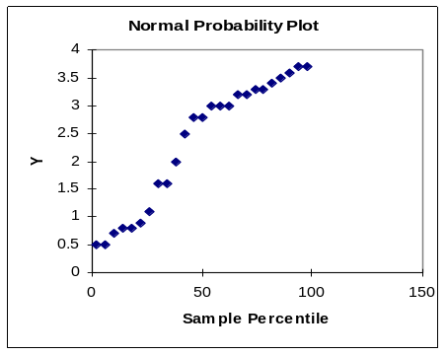
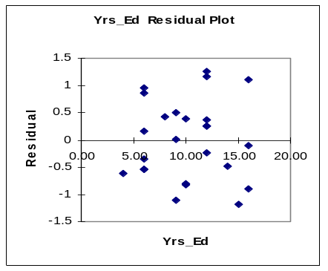
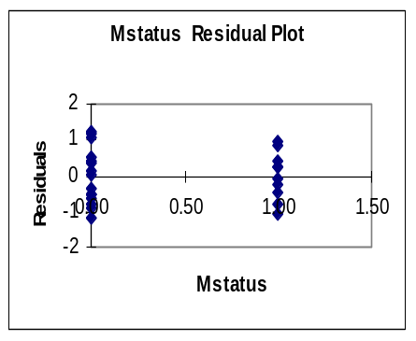

Again these plots are okay.
Modelling
This involves comparisons of different models.
The most suitable model is selected on the grounds of:
- making theoretical sense
- adequacy of fit
- explanatory power
- parsimony
Example:
Consider the case of modelling the miles per gallon of fuel used by cars - we might have explanatory variables of 0-60 acceleration, engine displacement, number of cylinders, weight of the car and year of manufacture.
This gives the model:

Regression Statistics
Multiple R | 0.899
R Square | 0.808
Adjusted R Square | 0.805
Standard Error | 3.440
Observations | 390

ANOVA
 | df | SS | MS | F | Sig F
Regression | 6 | 19048 | 3175 | 268 | 0
Residual | 383 | 4531 | 12
Total | 389 | 23580
 | Coefficients | SE | t Stat | P-value | Lower 95% | Upper 95%
Intercept | -14.655 | 4.803 | -3.051 | 0.002 | -24.099 | -5.211
Engine Displacement | 0.008 | 0.007 | 1.125 | 0.261 | -0.006 | 0.023
Horsepower | -0.001 | 0.014 | -0.087 | 0.931 | -0.029 | 0.027
Vehicle Weights | -0.007 | 0.001 | -10.12 | 0.000 | -0.008 | -0.005
Time to Accelerate | 0.080 | 0.104 | 0.771 | 0.441 | -0.125 | 0.285
Model Year | 0.758 | 0.053 | 14.33 | 0.000 | 0.654 | 0.862
Number of Cylinders | -0.367 | 0.335 | -1.097 | 0.274 | -1.025 | 0.291

So only weight and model year appear as significant yet the R-square is reasonable. The coefficient of weight is positive - the heavier the car the greater the mpg - surely not! Regressing on weight alone gives:

SUMMARY OUTPUT
Regression Statistics
Multiple R | 0.831
R Square | 0.690
Adjusted R Square | 0.689
Standard Error | 4.338
Observations | 391

ANOVA
 | df | SS | MS | F | Sig F
Regression | 1 | 16290 | 16290 | 865.645 | 5.884E-101
Residual | 389 | 7320 | 19
Total | 390 | 23610
 | Coefficients | Standard Error | t-Stat | P-value
Intercept | 46.200 | 0.803 | 57.557 | 0.000
Vehicle Weight (lbs.) | -0.008 | 0.000 | -29.422 | 0.000

With an R-square of 69%. So more sensible. It is also surprising that acceleration is not important, however, entering acceleration on its own gives:

These are typical of the effects of multicollinearity.

To test for this:

1. Examine the correlation matrix

 | Miles | Engine | Horse Power | Weight | Accelerate | Model Year | Cylinders
Miles per Gallon | 1
Engine | -0.805 | 1
Horse Power | -0.776 | 0.898 | 1
Weight | -0.831 | 0.934 | 0.863 | 1
Accelerate | 0.431 | -0.548 | -0.701 | -0.425 | 1
Model Year | 0.577 | -0.367 | -0.411 | -0.303 | 0.296 | 1
Cylinders | -0.776 | 0.951 | 0.842 | 0.897 | -0.511 | -0.342 | 1

So the independent variables are not independent a point emphasised by the matrix scatter plot:

Remedies

- Do not include the correlated variable(s).

In the previous example, weight is highly correlated with every other variable - so using only weight gives:

Model Summary
Regression Statistics
Multiple R | 0.831
R Square | 0.690
Adjusted R Square | 0.689
Standard Error | 4.338
 | Coefficients | Standard Error | t Stat | P-value
Intercept | 46.200 | 0.803 | 57.557 | 0.000
Vehicle Weight (lbs.) | -0.008 | 0.000 | -29.422 | 0.000
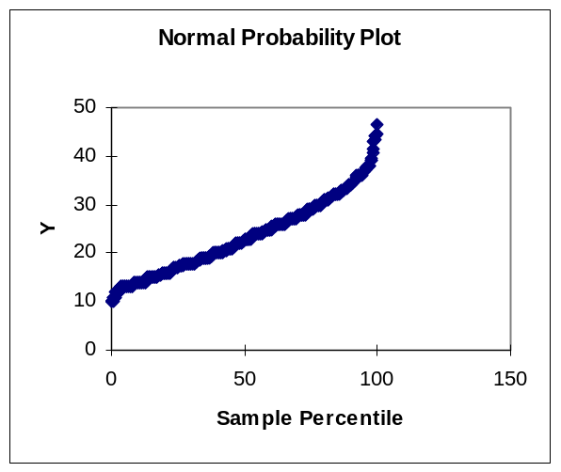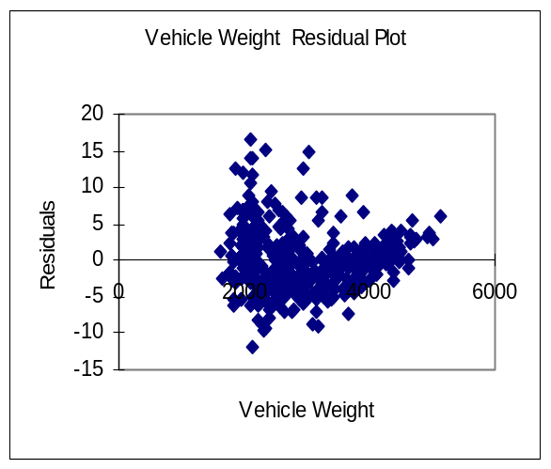

So some concerns with the residuals. Correcting this gives:

Here we are not worried about multicollinearity as it is essentially within the same variable.

There is evidence of increasing variance in the residuals for higher values of the predicted values. This is known as heteroscedasticity and to correct for this take logs of mpg which gives:

This has an R-square of 76.7%.

This looks better - but still some bad residuals - may be need other variables.

- Use Ridge Regression: This is an iterative procedure which adds or subtracts a small perturbation to the Hessian matrix of the explanatory variables to prevent the ill-conditioning which causes the estimation problems. It is a rather complex method and is not used very much.
- Use Factor Analysis (or principal Components) - this will be explained in the next unit.

- References

Bryman, A. and Crammer, D., 2004, Quantitative Data Analysis with SPSS 12 and 13: A Guide for Social Scientists, London, Routledge.

Ott, R. L., 1988, An introduction to Statistical Methods and Data Analysis, Belmont Ca, Duxbury.

Pardoe, I., 2004, Applied Regression Modeling: A Business Approach, Chichester, Wiley.

M. K. Pelosi, M. K. and T. M. Sandifer, T. M., 2002, Doing Statistics with EXCEL, Chichester, Wiley.

Exercises

The data that will be used in these examples is available on the web site.

Load the file SIMREG.XLS

1. Determine a model of the cost of stay in hospital (cost) which is dependent on the duration of stay in days (day).

Obtain the scatter plot

Correlation coefficient =

R-square =

Model =

Standard Errors of Coefficients =

Obtain the residual plot and test residuals for normality.

Predict how much an eight day and a twenty day stay will cost - which will be the most reliable?

- Determine a model of how sales volume (svol) depends on the number of contacts a salesperson has, Try a model of the form Y = a + b X and one of the form Y = a + b X + cX².

For Y = a + b X
R square =

Model =

Standard Errors of Coefficients =

For Y = a + b X + cX²
R square =

Model =

Standard errors of coefficients =

Which is the best model?
What do you conclude about the plausibility of this model over the long run?

3. A company reckons that sales are exponentially related to advertising expenditure. Use the data advertex and sales to test this hypothesis by fitting the model:

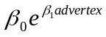sales =

Note that in EXCEL the exponential function is written as = exp(cell ref)

This can be re-expressed as

ln(sales) = β₀ + β₁advertex

R square =

Model =

Standard errors of coefficients =

4. Is there as relationship between heart attacks and wine consumption - use the variables, wine and heart.

Correlation coefficient =

R square =

Model =

Standard errors of coefficients =

5. Determine how demand for electricity (load) in California depends on temperature (temp).

Correlation coefficient =

R square =

Model =

Standard errors of coefficients =

6. The variables pe_ratio, profit, growth and employ are the price earnings ratio for 19 companies (firm) are their associated profit margins, percentage growth rates and number of employees in thousands. Obtain and interpret a multiple regression model with pe-ratio as the dependent variable.

Correlation coefficient =

R square =

Model =

Standard errors of coefficients =

7. The file Telser.xls contains data on the demand for cigarettes - use this data to
obtain a model of cigarette demand.

- File Work.xls contains job related items which might influence the hours worked by clerical staff. Obtain a model for hours worked.

The variables are: hours - hours worked
mail - the number of pieces of mail processed
money - number of money orders dealt with
window - number of window payments
cheques - number of cheques cashed
odd - number of odd transactions
bus - number of bus tickets sold.

(Ensure that you explore this data set for any oddities).

9. The following is a table of quarterly sales for a company for the last four years. Use a regression model to predict the sales in 1998.

 | Sales
Year | Quarter 1 | Quarter 2 | Quarter 3 | Quarter 4
1994 | 1000 | 800 | 550 | 1600
1995 | 1105 | 890 | 630 | 1808
1996 | 1180 | 970 | 780 | 1950
1997 | 2050 | 1020 | 830

To do this make use of dummy variables to represent the quarter, that is create a variable D1 that will have the value 1 if it refers to quarter 1 and zero otherwise. Similarly create variables D2 and D3 to represent quarters 2 and 3. We do not need a variable for quarter 4 because if D1, D2 and D3 are all 0 then this implies quarter 4.

